

**Green University of Bangladesh**

**Department of Computer Science and Engineering (CSE)**

**Faculty of Sciences and Engineering**

**Semester: (Spring, Year:2021), B.Sc. in CSE (Day)**

**LAB REPORT NO #2**

**Course Title: Structured Programming Lab**

**Course Code: 104 Section: D4**

**Lab Experiment Name: Introduction to Expression in C**

**Student Details**

| **Name** | | **ID** |
| --- | --- | --- |
| **1.** | Md. Maruf Sarker | 221002063 |

**Lab Date : 21-6-22**

**Submission Date : 28-6-22**

**Course Teacher’s Name : Ahmed Iqbal Pritom**

**[For Teachers use only: Don’t Write Anything inside this box]**

| **Lab Report Status**  **Marks: ………………………………… Signature:.....................**  **Comments:.............................................. Date:..............................** |
| --- |

**1. TITLE OF THE LAB EXPERIMENT**

Introduction to Expression in C

**2. OBJECTIVES/AIM [1]**

1. Take the base and heigh of a triangle and calculate its area.
2. Take the radius of a circle and calculate area and cicumsference.
3. Take 2 numbers from user. Find sum, sub, product, division between the 2 number.
4. Take today's temperature(in degree celsius) from user. Convert it into fahrenheit.
5. Take a two digit number from user. Print the reverse of the number.
6. Take an employee's salary as input(int BDT). Convert it into USD.
7. Swap the values of the variables with/without using any third variable.
8. Find the roots of a quardratic equation(ax^2 + bx + c = 0).
9. Find the linear distance between two points in a cartesian coordinate system.
10. Write a C Program to enter the amount in dollars and then display the amount by adding 18% as tax. [value=(money + (money * 0.18))]
11. Write a C program to convert a given integer (in seconds) to hours, minutes and seconds.

**3. PROCEDURE / ANALYSIS / DESIGN [2]**

**Task-1:**

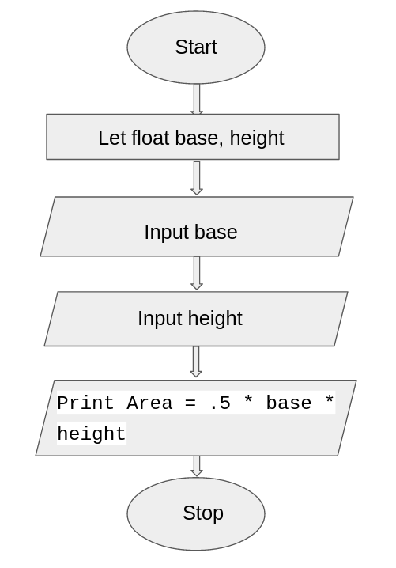

**Task-2:**

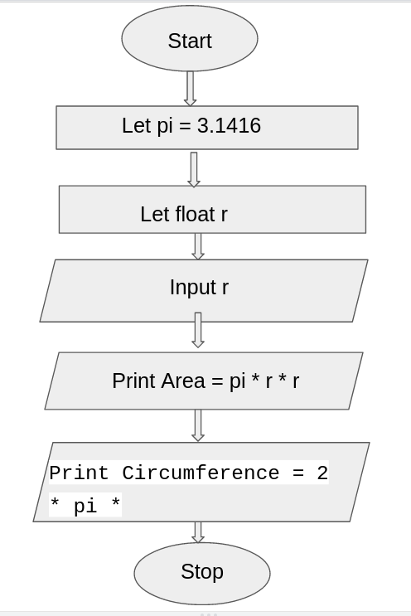

**Task-3:**

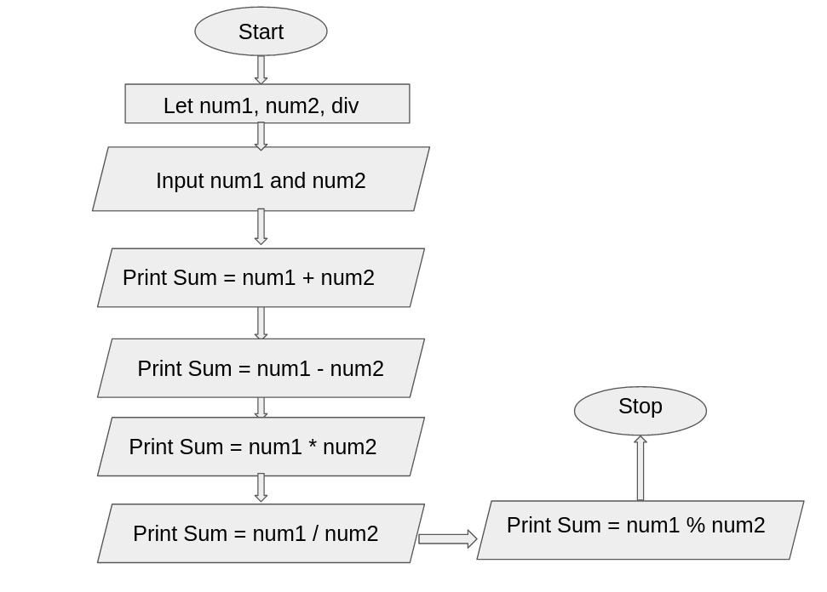

**Task-4:**

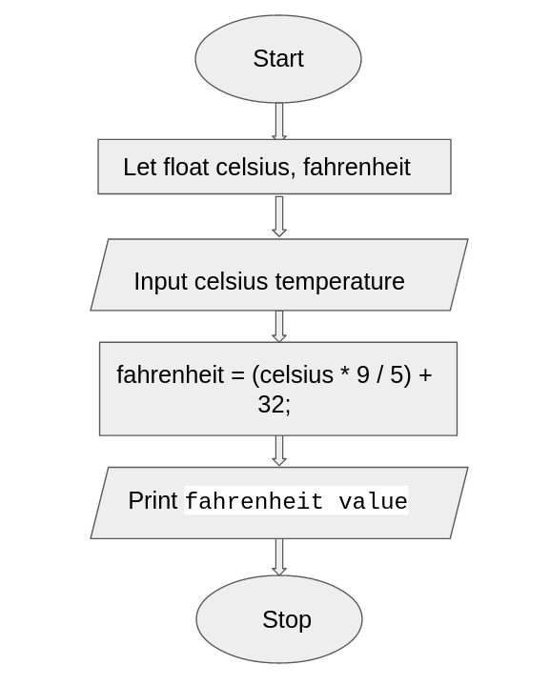

**Task-5:**

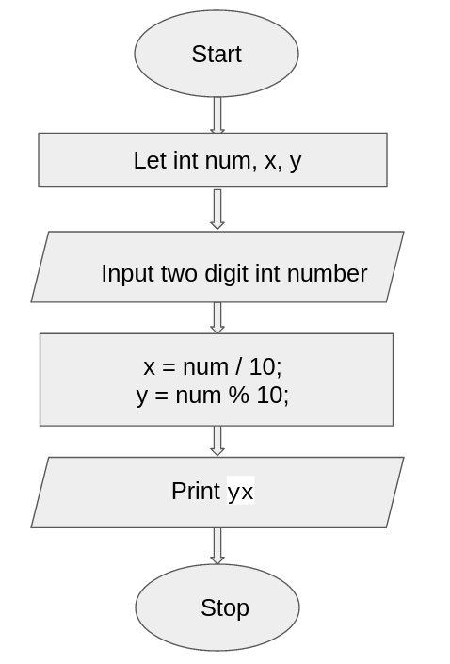

**Task-6:**

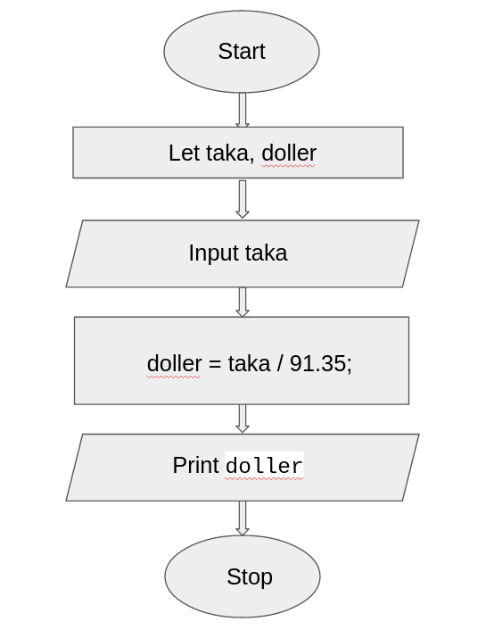

**Task-7:**

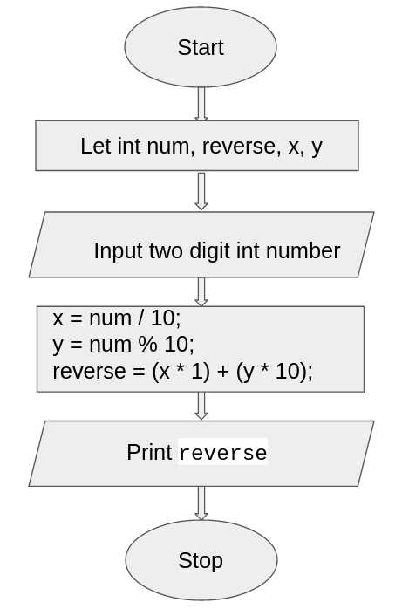

**Task-8:**

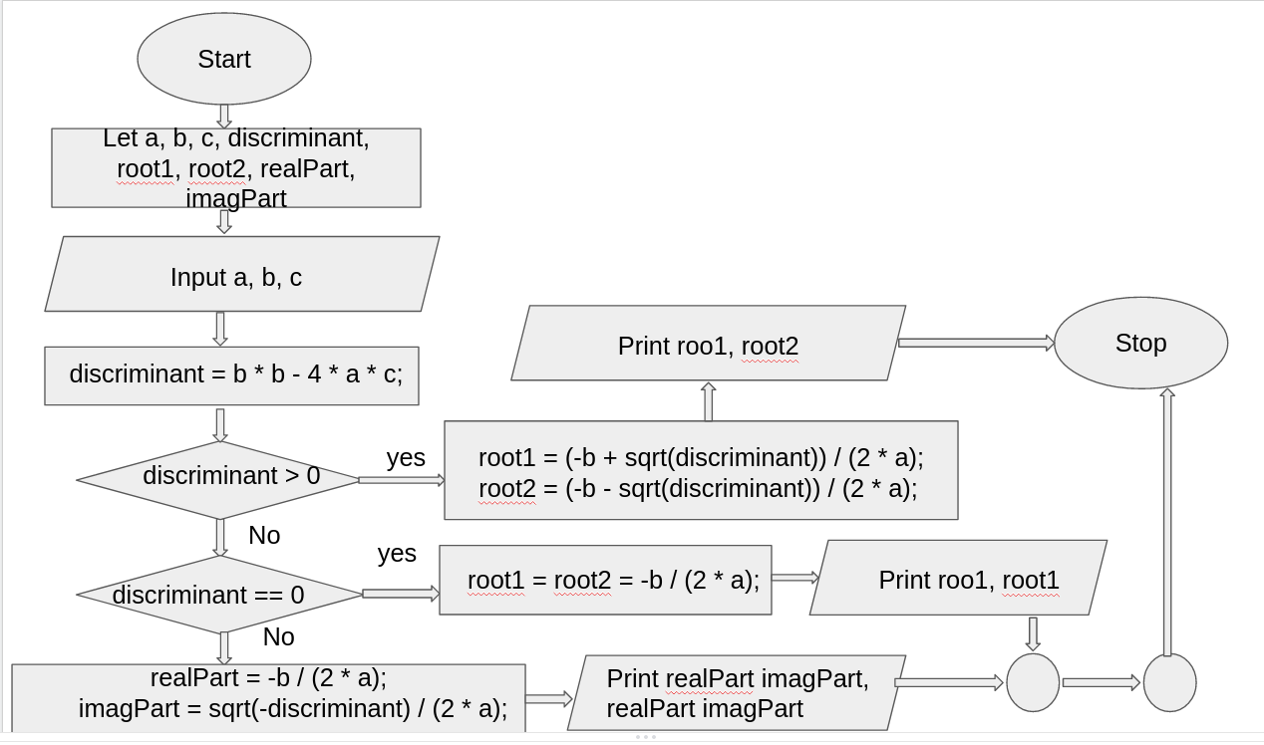

**Task-9:**

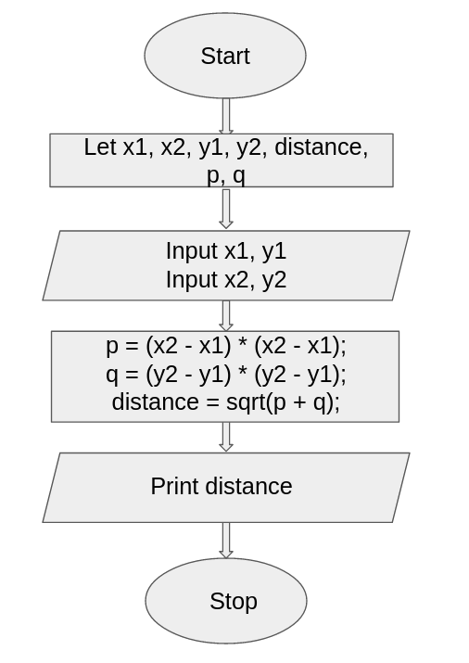

**Task-10:**

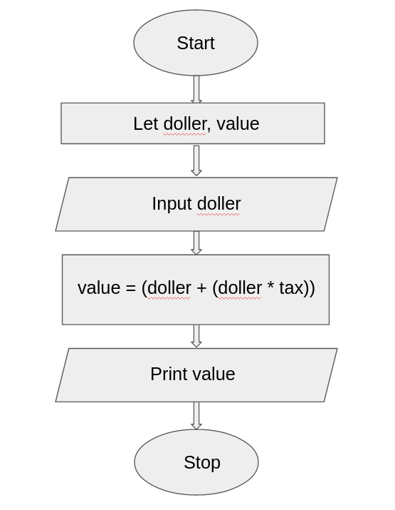

**Task-11:**

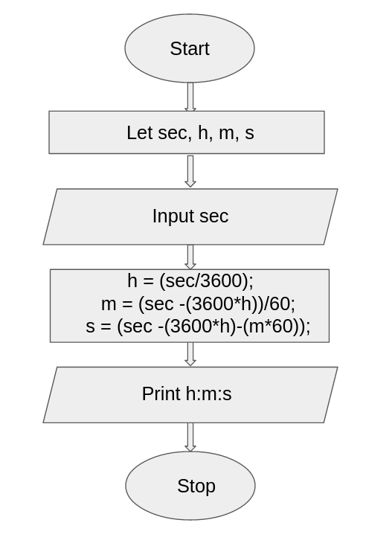

**4. IMPLEMENTATION [2]**

**Task-1:**

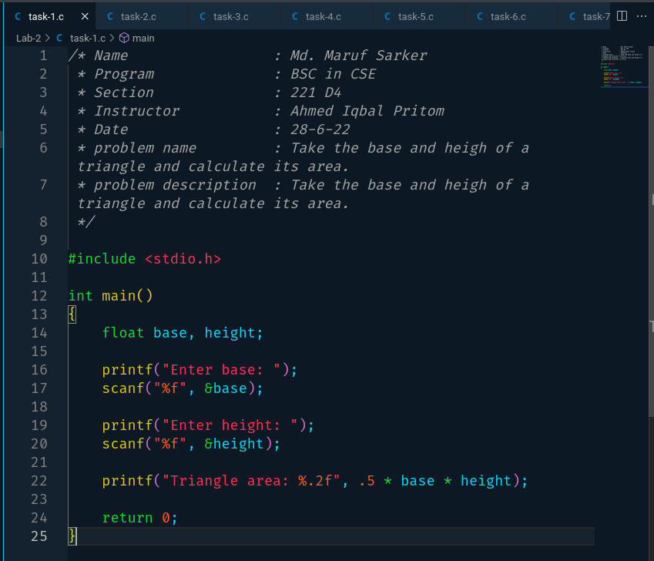

**Task-2:**

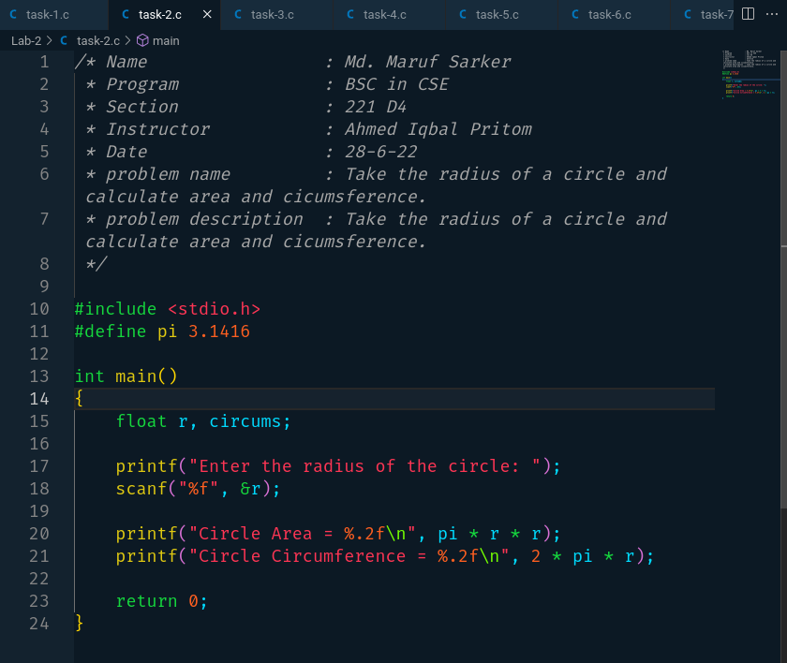

**Task-3:**

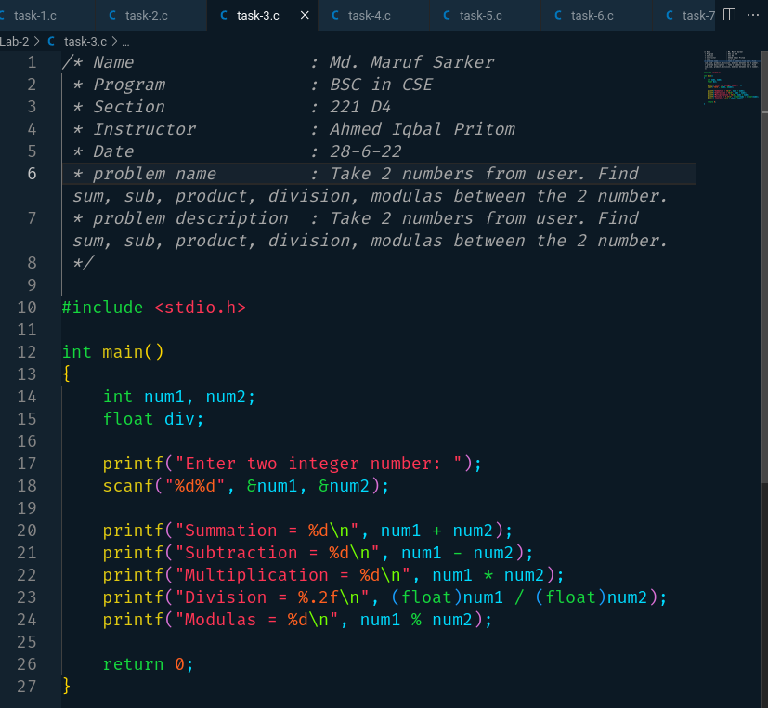

**Task-4:**

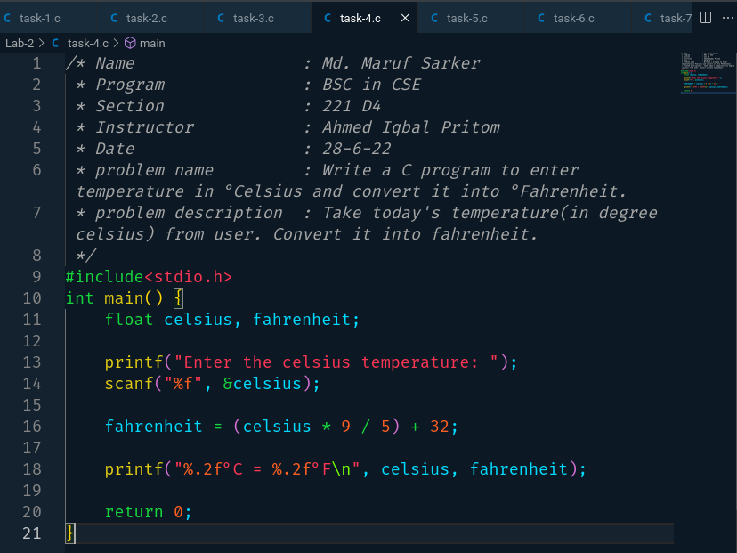

**Task-5:**

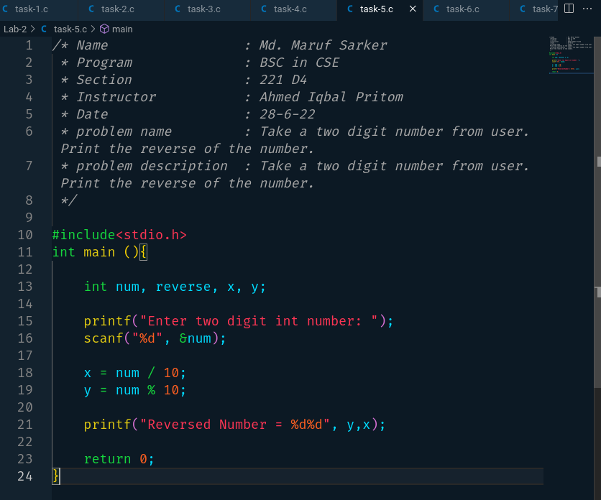

**Task-6:**

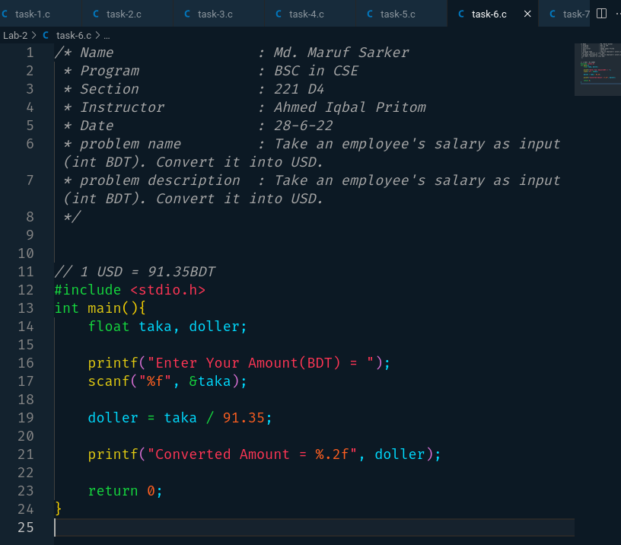

**Task-7:**

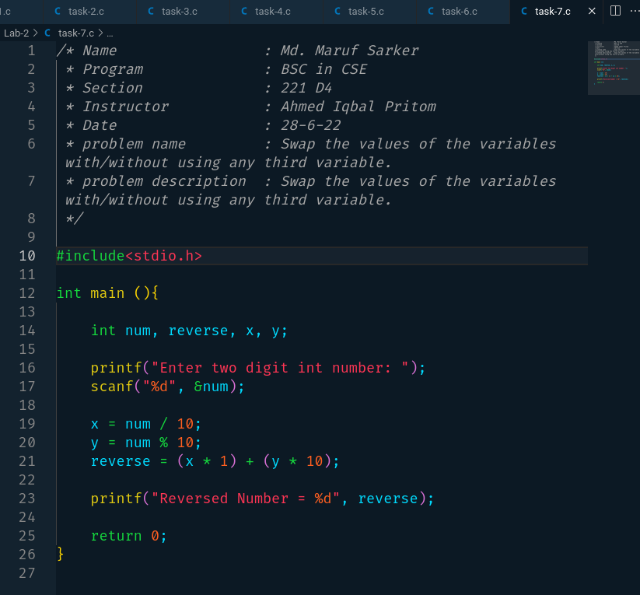

**Task-8:**

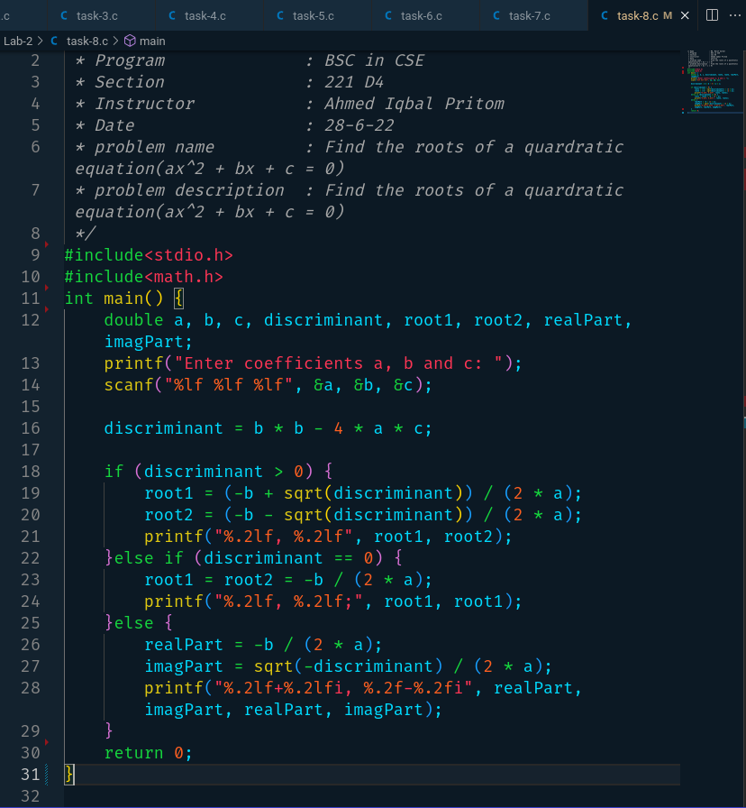

**Task-9:**

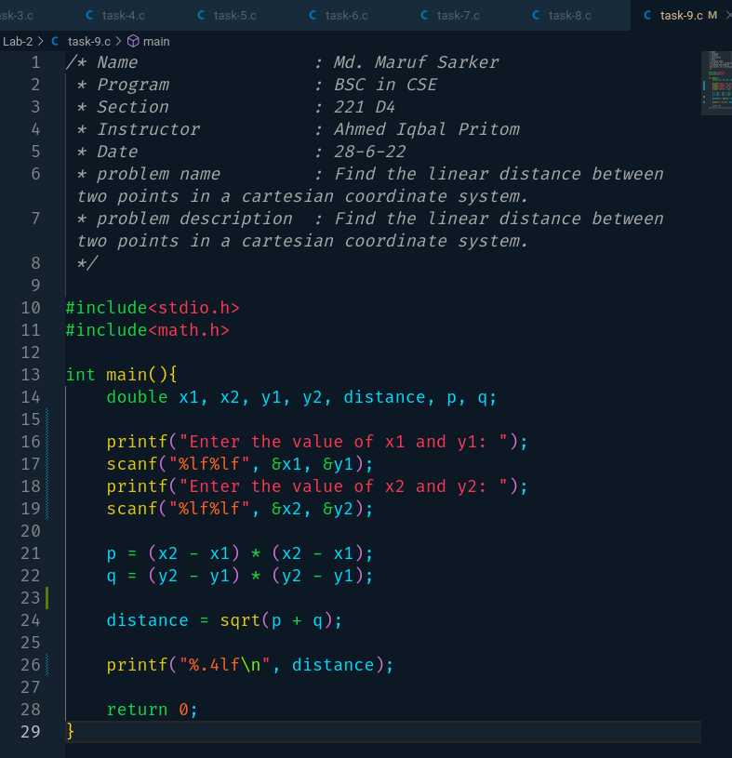

**Task-10:**

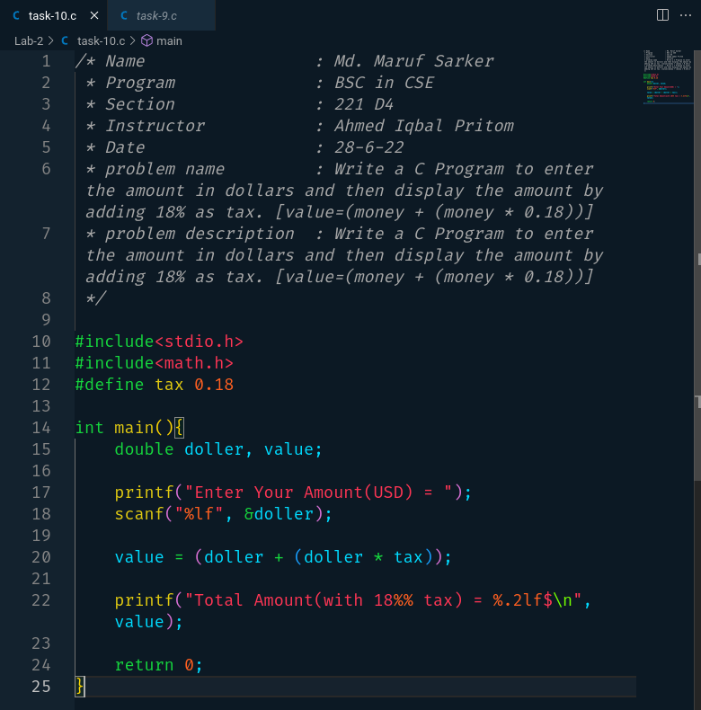

**Task-11:**

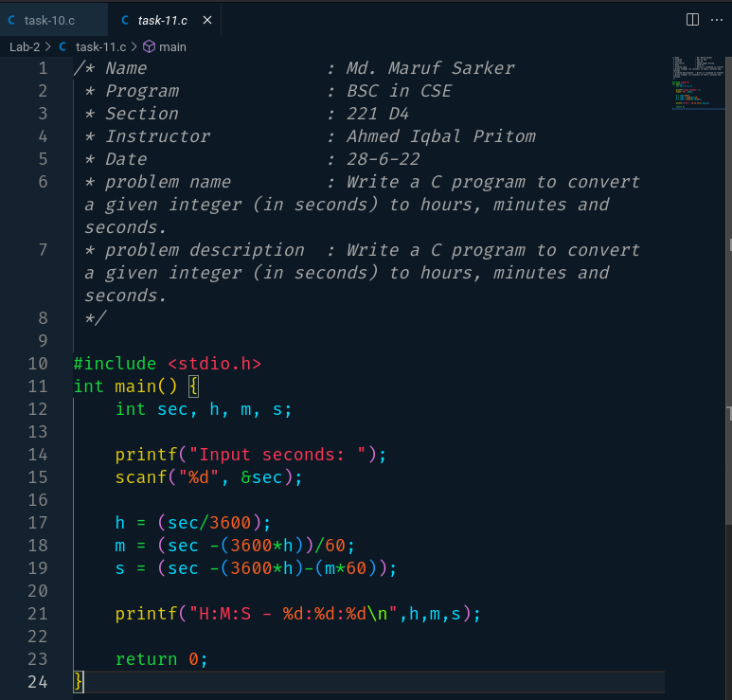

**5. TEST RESULT / OUTPUT [2]**

**Task-1:**

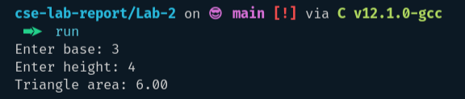

**Task-2:**

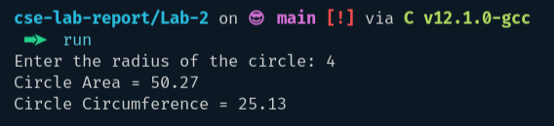

**Task-3:**

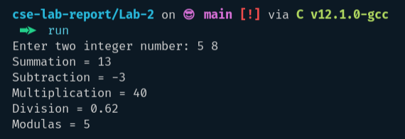

**Task-4:**

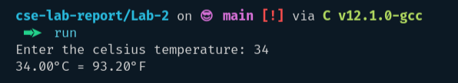

**Task-5:**

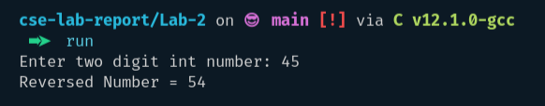

**Task-6:**

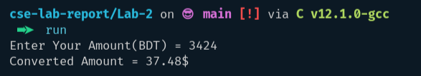

**Task-7:**

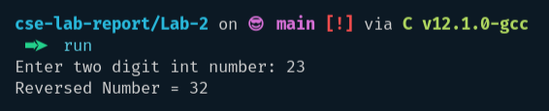

**Task-8:**

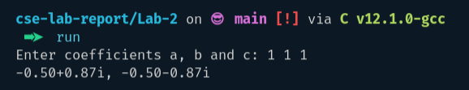

**Task-9:**

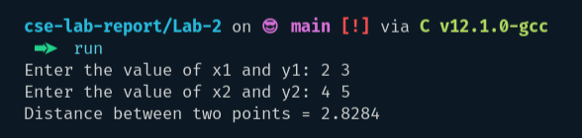

**Task-10:**

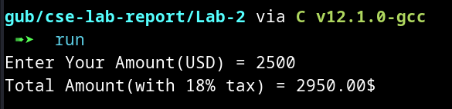

**Task-11:**

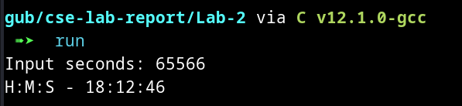

**6. ANALYSIS AND DISCUSSION [2]**

1. Everything is good. The output results in the previous section.
2. Everything is interesting.
3. Find the roots of a quadratic equation(ax^2 + bx + c = 0), Write a C program to convert a given integer (in seconds) to hours, minutes, and seconds*.*

Those are the trouble spots while completing this assignment.

1. Find the roots of a quadratic equation(ax^2 + bx + c = 0). Calculating imaginary numbers is the most difficult part of my program to implement.
2. Those problem sets are perfect for a beginner.
3. I learned a lot of things from those problem sets. I learned to calculate temperature, calculate the area of triangles and circles, reverse a number in different ways, calculate quadratic equations, and calculate the distance between two points.
4. Now I have the ability to write a program and I have the confidence to solve beginners level problems. Cause I learned data types, and condition operators(if-else if-else, switch)